Constraints:
Constraints enforce rules at table level. Constraints prevent deletion of tables if there is dependency. Prevent invalid data entry into tables.
Valid constraints:
- NOT NULL
- UNIQUE
- FOREIGN KEY
- PRIMARY KEY
- CHECK
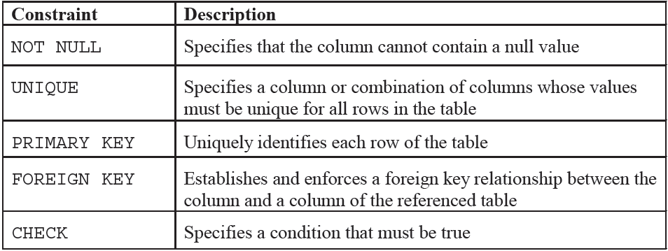

UNIQUE

Every value in a column need to be unique
A unique key is a set of one or more than one fields/columns of a table that uniquely identify a record in a database table.
Like primary key but it can accept only one null value and it cannot have duplicate values.
The unique key and primary key both provide a guarantee for uniqueness for a column or a set of columns.
There may be many unique key constraints for one table, but only one PRIMARY KEY constraint for one table.

Eg:
SQL Server / Oracle / MS Access:
(Defining a unique key constraint on single column)://one null value
CREATE TABLE students (S_Id int NOT NULL UNIQUE, LastName varchar (25) NOT NULL,
FirstName varchar (25), City varchar (25))
MySQL:
CREATE TABLE students ( S_Id int(5) NOT NULL, LastName varchar (255) NOT NULL,
FirstName varchar (255), City varchar (255), UNIQUE (S_Id))

(Defining a unique key constraint on multiple columns):
MySQL / SQL Server / Oracle / MS Access:
CREATE TABLE students (S_Id int NOT NULL, LastName varchar (255) NOT NULL, FirstName varchar (255), City varchar (255), CONSTRAINT uc_studentId UNIQUE (S_Id, LastName))
SQL UNIQUE KEY constraint on ALTER TABLE:
If you want to create a unique constraint on "S_Id" column when the table is already created, you should use the following SQL syntax:
(Defining a unique key constraint on single column):
MySQL / SQL Server / Oracle / MS Access:
ALTER TABLE students ADD UNIQUE (S_Id)
(Defining a unique key constraint on multiple columns):
MySQL / SQL Server / Oracle / MS Access:
ALTER TABLE students ADD CONSTRAINT uc_StudentId UNIQUE (S_Id, LastName)
DROP SYNTAX FOR A FOREIGN KEY constraint:
If you want to drop a UNIQUE constraint, use the following SQL syntax:

MySQL:
ALTER TABLE students DROP INDEX uc_studentID
SQL Server / Oracle / MS Access:
ALTER TABLE students DROP CONSTRAINT uc_studentID

NOT NULL:
To select records with no null values.
It ensures no row contains null value. Not null constraint must be declared in column level.
Eg:
SELECT SIR_NAME, FIRSTNAME, MARKS FROM STUDENTS
WHERE MARKS IS NOT NULL

Constraint declaration:
CREATE TABLE Persons ( ID int NOT NULL, LastName varchar(255) NOT NULL,
FirstName varchar(255), Age int,
CONSTRAINT UC_Person UNIQUE (ID,LastName));
Primary Key:
It creates primary key of a table. There can be only one primary key created for each table. It is unique and not allows null value.
A column or columns is called primary key (PK) that uniquely identifies each row in the table.
If you want to create a primary key, you should define a PRIMARY KEY constraint when you create or modify a table.
When multiple columns are used as a primary key, it is known as composite primary key.
In designing the composite primary key, you should use as few columns as possible. It is good for storage and performance both, the more columns you use for primary key the more storage space you require.

Points to remember for primary key:
- Primary key enforces the entity integrity of the table.
- Primary key always has unique data.
- A primary key length cannot be exceeded than 900 bytes.
- A primary key cannot have null value.
- There can be no duplicate value for a primary key.
- A table can contain only one primary key constraint.

Advantage of primary key:
The main advantage of this uniqueness is that we get fast access.
SQL Server, Oracle, MS Access:// 354677
CREATE TABLE students (S_Id int NOT NULL PRIMARY KEY,
LastName varchar (255) NOT NULL,
FirstName varchar (255),
Address varchar (255),
City varchar (255))
MySQL:
CREATE TABLE students (S_Id int NOT NULL, LastName varchar (255) NOT NULL,
FirstName varchar (255), Address varchar (255),
City varchar (255), PRIMARY KEY (S_Id))

Primary key for multiple columns:
MySQL, SQL Server, Oracle, MS Access:
CREATE TABLE students (S_Id int NOT NULL, LastName varchar (255) NOT NULL,
FirstName varchar (255), Address varchar (255),
City varchar (255), CONSTRAINT pk_StudentID PRIMARY KEY (S_Id, LastName) )

Primary key on ALTER TABLE
When table is already created and you want to create a PRIMARY KEY constraint on the "S_Id" column you should use the following SQL:
Primary key on one column:
ALTER TABLE students ADD PRIMARY KEY (S_Id)
Primary key on multiple column:
ALTER TABLE students ADD CONSTRAINT pk_StudentID
PRIMARY KEY (S_Id,LastName)

DROP a PRIMARY KEY constraint
If you want to DROP (remove) a primary key constraint, you should use following syntax:
MySQL:
ALTER TABLE students DROP PRIMARY KEY
SQL Server / Oracle / MS Access:
ALTER TABLE students DROP CONSTRAINT pk_StudentID

Foreign Key:
It is also called as referential integrity. Foreign key constraint establishes relation between primary key
In the relational databases, a foreign key is a field or a column that is used to establish a link between two tables.
In simple words you can say that, a foreign key in one table used to point primary key in another table.
- The "S_Id" column in the "Students" table is the PRIMARY KEY in the "Students" table.
- The "S_Id" column in the "Orders" table is a FOREIGN KEY in the "Orders" table.
The foreign key constraint is generally prevents action that destroy links between tables.
It also prevents invalid data to enter in foreign key column.

FOREIGN KEY constraint ON CREATE TABLE:
(Defining a foreign key constraint on single column)
To create a foreign key on the "S_Id" column when the "Orders" table is created:
MySQL:
CREATE TABLE orders ( O_Id int NOT NULL, Order_No int NOT NULL, S_Id int, PRIMARY KEY (O_Id), FOREIGN KEY (S_Id) REFERENCES Persons (S_Id))

Persons Orders
Primary Key Foregin Key(S_Id)
S_ID O_Id

SQL Server /Oracle / MS Access:
CREATE TABLE Orders ( O_Id int NOT NULL PRIMAY KEY, Order_No int NOT NULL, S_Id int FOREIGN KEY REFERENCES persons (S_Id) )

FOREIGN KEY constraint for ALTER TABLE:
If the Order table is already created and you want to create a FOREIGN KEY constraint on the "S_Id" column, you should write the following syntax:
Defining a foreign key constraint on single column:
MySQL / SQL Server / Oracle / MS Access:
ALTER TABLE Orders ADD CONSTRAINT fk_PerOrders FOREIGN KEY(S_Id)
REFERENCES Students (S_Id)

DROP SYNTAX for FOREIGN KEY CONSTRAINT:
If you want to drop a FOREIGN KEY constraint, use the following syntax:
MySQL:
ALTER TABLE Orders DROP FOREIGN KEY fk_PerOrders
SQL Server / Oracle / MS Access:
ALTER TABLE DROP CONSTRAINT fk_PerOrders

Difference between primary key and foreign key in SQL:
- These are some important difference between primary key and foreign key in SQL-
- Primary key cannot be null on the other hand foreign key can be null.
- Primary key is always unique while foreign key can be duplicated.
- Primary key uniquely identify a record in a table while foreign key is a field in a table that is primary key in another table.
- There is only one primary key in the table on the other hand we can have more than one foreign key in the table.
- By default primary key adds a clustered index on the other hand foreign key does not automatically create an index, clustered or non-clustered. You must manually create an index for foreign key.

Composite Key
A composite key is a combination of two or more columns in a table that can be used to uniquely identify each row in the table when the columns are combined uniqueness is guaranteed, but when it taken individually it does not guarantee uniqueness.
Sometimes more than one attributes are needed to uniquely identify an entity. A primary key that is made by the combination of more than one attribute is known as a composite key.
MySQL, Oracle,SQL:
CREATE TABLE SAMPLE_TABLE (COL1 integer, COL2 varchar(30), COL3 varchar(50),
PRIMARY KEY (S-id, email));

Alternate Key in SQL:
Alternate key is a secondary key it can be simple to understand by an example:
Example of student it can contain NAME, ROLL NO., ID and CLASS.
Here ROLL NO. is primary key and rest of all columns like NAME, ID and CLASS are alternate keys.
If a table has more than one candidate key, one of them will become the primary key and rest of all are called alternate keys.
In simple words,
That any of the candidate key which is not part of primary key is called an alternate key.
So alternate key, the column may not be primary key but still it is a unique key in the column.

Note: An alternate key is just a candidate key that has not been selected as the primary key

{ALTERNATE KEYS is a column or group of columns in a table that uniquely identify every row in that table.
A table can have multiple choices for a primary key but only one can be set as the primary key. All the keys which are not primary key are called an Alternate Key.}
Example:
In this table, StudID, Roll No, Email are qualified to become a primary key. But since StudID is the primary key, Roll No, Email becomes the alternative key.
StudID | Roll No | First Name | LastName | Email
1 | 11 | Tom | Price | abc@gmail.com
2 | 12 | Nick | Wright | xyz@gmail.com
3 | 13 | Dana | Natan | mno@yahoo.com

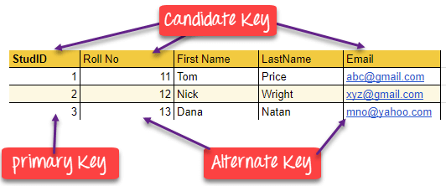

CANDIDATE KEY
-is a set of attributes that uniquely identify tuples in a table. Candidate Key is a super key with no repeated attributes.
-The Primary key should be selected from the candidate keys.
- Every table must have at least a single candidate key.
- A table can have multiple candidate keys but only a single primary key.
Properties of Candidate key:
- It must contain unique values
- Candidate key may have multiple attributes
- Must not contain null values
- It should contain minimum fields to ensure uniqueness
- Uniquely identify each record in a table

Example: In the given table Stud ID, Roll No, and email are candidate keys which help us to uniquely identify the student record in the table.
StudID | Roll No | First Name | LastName | Email
1 | 11 | Tom | Price | abc@gmail.com
2 | 12 | Nick | Wright | xyz@gmail.com
3 | 13 | Dana | Natan | mno@yahoo.com

- Super Key - A super key is a group of single or multiple keys which identifies rows in a table.
- Primary Key - is a column or group of columns in a table that uniquely identify every row in that table.
- Candidate Key - is a set of attributes that uniquely identify tuples in a table. Candidate Key is a super key with no repeated attributes.
- Alternate Key - is a column or group of columns in a table that uniquely identify every row in that table.
- Foreign Key - is a column that creates a relationship between two tables. The purpose of Foreign keys is to maintain data integrity and allow navigation between two different instances of an entity.
- Compound Key - has two or more attributes that allow you to uniquely recognize a specific record. It is possible that each column may not be unique by itself within the database.
- Composite Key - An artificial key which aims to uniquely identify each record is called a composite key. These kinds of key are unique because they are created when you don't have any natural primary key.
FirstName---- Revathi ---101—dept-- testing
Revathi—459-- development
Revathi—345-- designing

The difference between compound and the composite key is that any part of the compound key can be a foreign key, but the composite key may or maybe not a part of the foreign key.

CHECK:

CHECK Constraint
The CHECK constraint is used to limit the value range that can be placed in a column.
If you define a CHECK constraint on a column it will allow only certain values for this column.
If you define a CHECK constraint on a table it can limit the values in certain columns based on values in other columns in the row.

SQL CHECK on CREATE TABLE
The following SQL creates a CHECK constraint on the "Age" column when the "Persons" table is created. The CHECK constraint ensures that the age of a person must be 18, or older:
MySQL, SQL Server / Oracle / MS Access:
CREATE TABLE Persons ( ID int NOT NULL, LastName varchar(25) NOT NULL,
FirstName varchar(25), Age int, CHECK (Age>=18));
Multiple columns:
MySQL / SQL Server / Oracle / MS Access:
CREATE TABLE Persons (ID int NOT NULL, LastName varchar(25) NOT NULL,
FirstName varchar(25),Age int, City varchar(25),
CONSTRAINT CHK_Person CHECK (Age>=18 AND City=’Chennai’));

Select *from user_tables

